13.84: a) As the mass approaches the origin, the motion is that of a mass attached to a spring of spring constant k, and the time to reach the origin is 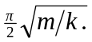 After passing through the origin, the motion is that of a mass attached to a spring of spring constant 2k and the time it takes to reach the other extreme of the motions is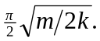 The period is twice the sum of these times, or 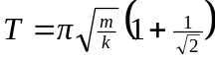. The period does not depend on the amplitude, but the motion is not simple harmonic. B) From conservation of energy, if the negative extreme is 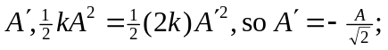 the motion is not symmetric about the origin.

